Ecosphere

Article, Macrosystems Ecology

Diverse migratory portfolios drive inter-annual switching behavior of elk across the Greater Yellowstone Ecosystem

Gabriel R. Zuckerman*1, Kristin J. Barker1, Laura C. Gigliotti1, Eric K. Cole4, Justin A. Gude5, Mark A. Hurley3, Matthew J. Kauffman6, Daryl Lutz2, Daniel R. MacNulty8, Eric J. Maichak2, Doug McWhirter2, Tony W. Mong2, Kelly Proffitt5, Brandon M. Scurlock2, Daniel R. Stahler7, Ben Wise2, and Arthur D. Middleton1

* Corresponding author: [gzuckerman@berkeley.edu](mailto:gzuckerman@berkeley.edu)

1 Department of Environmental Science, Policy and Management; University of California, Berkeley; Berkeley, CA, USA

2 Wyoming Game and Fish Department; Wyoming, USA

3 Idaho Department of Fish and Game; Boise, ID, USA

4 National Elk Refuge; US Fish and Wildlife Service; Jackson, WY, USA

5 Montana Fish, Wildlife & Parks; Helena, MT, USA

6 U.S. Geological Survey; Wyoming Cooperative Fish and Wildlife Research Unit; Department of Zoology and Physiology; University of Wyoming; Laramie, WY, USA

7 Yellowstone Center for Resources; Yellowstone National Park, WY, USA

8 Department of Wildland Resources and Ecology Center, Utah State University; Logan, UT, USA

Open Research Statement: The novel code for the statistical analyses performed in this manuscript is archived this Github repository (<https://github.com/gabezuckerman/Plasticity1> [will be made more reader friendly prior to publication]). The movement data used in this study are not publicly available, as they are primarily owned by the state in which they occur, or by the universities that collected the data. The movement data were obtained for this project by undertaking numerous data sharing memorandums of understanding (MOU) with various state agencies, universities and researchers that did not include the public dispersal of the data.

For data requests regarding the Madison, North Madison, Mill Creek, Silver Run, Blacktail and Greeley herds, please reach out to Justin Gude ([jgude@mt.gov](mailto:jgude@mt.gov)) or Kelly Proffitt ([kproffitt@mt.gov](mailto:kproffitt@mt.gov)) from Montana Department of Fish, Wildlife and Parks. A formal memorandum of understanding may be required for data use.

For data requests regarding the Northern herd, please reach out to Daniel Stahler ([Daniel_stahler@nps.gov](mailto:Daniel_stahler@nps.gov)) from Yellowstone Center for Resources or Daniel MacNulty ([dan.macnulty@usu.edu](mailto:dan.macnulty@usu.edu) ) from the Department of Wildland Resources and Ecology Center, Utah State University. A formal memorandum of understanding may be required for data use.

For data requests regarding the Clarks Fork herd, please reach out to Matthew Kauffman ([mkauffm1@uwyo.edu](mailto:mkauffm1@uwyo.edu)) from the U.S. Geological Survey; Wyoming Cooperative Fish and Wildlife Research Unit or Doug McWhirter ([doug.mcwhirter@wyo.gov](mailto:doug.mcwhirter@wyo.gov)) from the Wyoming Game and Fish Department. A formal memorandum of understanding may be required for data use.

For data requests regarding the Cody herd, please reach out to Tony Mong ([tony.mong@wyo.gov](mailto:tony.mong@wyo.gov)) from Wyoming Game and Fish Department. A formal memorandum of understanding may be required for data use.

For data requests regarding the Jackson herd, please reach out to Eric Cole ([eric_cole@fws.gov](mailto:eric_cole@fws.gov)) from the National Elk Refuge; US Fish and Wildlife Service or Doug McWhirter ([doug.mcwhirter@wyo.gov) from](mailto:doug.mcwhirter@wyo.gov)%20from) the Wyoming Game and Fish Department. A formal memorandum of understanding may be required for data use.

For data requests regarding the Targhee herd, please reach out to Mark Hurley ([mark.hurley@idfg.idaho.gov](mailto:mark.hurley@idfg.idaho.gov)) from Idaho Department of Game and Fish. A formal memorandum of understanding may be required for data use.

For data requests regarding the Wiggins Fork herd, please reach out to Daryl Lutz (daryl.lutz@wyo.gov) from the Wyoming Game and Fish Department. A formal memorandum of understanding may be required for data use.

For data requests regarding the Gooseberry herd, please reach out to Eric Maichack ([eric.maichak@wyo.gov](mailto:eric.maichak@wyo.gov)) from the Wyoming Game and Fish Department. A formal memorandum of understanding may be required for data use.

For data requests regarding the Green River, Afton, Fall Creek, Hoback, Pinedale, South Wind River and Piney herds, please reach out to Brandon Scurlock ([brandon.scurlock@wyo.gov](mailto:brandon.scurlock@wyo.gov)) from the Wyoming Game and Fish Department. A memorandum of understanding may be required for data use.

Other datasets utilized for this research were retrieved from MODIS/Terra Surface Reflectance satellite imagery (<https://cmr.earthdata.nasa.gov/search/concepts/C193529944-LPDAAC_ECS.html> [Vermote, 2015]); the Snow Data Assimilation System (SNODAS; <https://nsidc.org/data/g02158/versions/1> [National Operational Hydrologic Remote Sensing Center, 2004]); the Land Change Monitoring, Assessment, and Projection (LCMAP; <https://www.usgs.gov/special-topics/lcmap/lcmap-data-access> [Pengra et al. 2020]); and an updated version of the Wyoming Game and Fish Department’s Feed Ground Locations shapefile (original: <https://wgfd.wyo.gov/Wildlife-in-Wyoming/Geospatial-Data/Big-Game-GIS-Data>; updated: <https://github.com/gabezuckerman/Plasticity1/tree/main/covariates/feed/data>). For each of the previously mentioned open-source datasets, the query details are discussed in the “Covariate Extraction” section in the “Methods”.

Key Words: elk; GPS tracking; Greater Yellowstone Ecosystem; migratory plasticity; migratory portfolios; migratory tactic; movement ecology; partial migration; switching behavior.

**Abstract**

A growing body of evidence shows that some ungulates alternate between migratory and non-migratory behaviors among years. Yet it remains unclear whether such short-term behavioral changes can help explain reported declines in ungulate migration worldwide, as opposed to long-term demographic changes or shorter-term behavioral changes. Furthermore, advances in tracking technology reveal that a simple distinction between migration and non-migration may not sufficiently describe all individual behaviors. To better understand the dynamics and drivers of ungulate switching behavior, we investigated 14 years of movement data from 361 elk in 20 herds across the Greater Yellowstone Ecosystem. First, we categorized yearly individual behaviors using a clustering algorithm that identified similar migratory tactics across a continuum of behaviors. Then, we tested 7 hypotheses to explain why some ungulates switch behaviors, and we evaluated how behavioral changes affected the proportions of different behaviors across the system. We identified four distinct behavioral tactics: residents (4.8% of elk-years), short distance migrants (53.7%), elevational migrants (21.9%) and long-distance migrants (19.6%). Of the 20 herds, 18 were partially migratory, and five had all four movement tactics present. We observed switches between migratory tactics in all sets of consecutive years during our study period, with an average of 22.5% of individual elk changing movement tactics from one year to the next. Elk in herds with higher movement tactic diversity were significantly more likely to switch tactics, and often responded more effectively to adverse environmental conditions, than those in herds with low movement tactic diversity. Switching increased the prevalence of both short- and long-distance migrants, decreased the prevalence of elevational migrants, and had no effect on the prevalence of residents during the time of our study. Our findings suggest that rather than contributing to the declining migratory behavior found in the GYE, switching behavior may help enable its long-term persistence.

**Introduction**

Partial migration, in which varied migratory and non-migratory movements occur in a single population (Lundberg, 1988, Chapman et al. 2011), occurs across taxa including invertebrates (Hansson and Hylander, 2009), fish (O’Neal and Stanford, 2011), birds (Lundberg, 1988) and mammals (Berg et al. 2019; Gowan et al. 2019). Partial migration can be maintained by demographic processes driven by differential fitness benefits of migratory tactics (e.g., Hebblewhite and Merrill, 2011; Cole et al. 2015) or by behavioral plasticity driven by interacting intrinsic and extrinsic influences (e.g. genes [Pulido et al. 2011], animal age [Clutton-Brock, 1984], reproductive status [Berg et al. 2019], forage availability [Fryxell and Sinclair 1988], climate [Xu et al. 2021], anthropogenic influence [Barker et al. 2019b], socio-cultural learning [Dodson 1988]). A clear grasp of the drivers of behavioral plasticity is a critical, yet often missing, first step to understanding adaptations of migratory species amid rapid climatic and anthropogenic change (Middleton et al. 2020; Xu et al. 2021).

Advanced tracking of animal movements has revealed growing evidence of individuals switching between migratory and non-migratory tactics from one year to the next, suggesting that behavioral plasticity may play a key role in maintaining partial migration. For ungulates in particular, recent work indicates many individuals switch migratory tactics, although switching rates vary considerably within and among species (e.g., mule deer (*Odocoileus hemionus*), Sawyer et al. 2018, van de Kerk et al. 2021; bighorn sheep (*Ovis canadensis)*, Spitz et al. 2018, Lowrey et al. 2020). Because few studies have investigated the drivers of switching behaviors, the causes of variation in this behavioral plasticity are not well understood (Picardi et al. 2020; Lowrey et al. 2020; Denryter et al. 2021). For instance, reported switching rates of elk (*Cervus canadensis*) range from 0% for one herd in the eastern Greater Yellowstone Ecosystem (GYE; Middleton et al. 2013) and 0.2% for another in the southern GYE (Cole et al. 2015), to 23% for a herd in Banff National Park (Eggeman et al. 2016), and up to 53% for one set of consecutive years in the North Sapphire Mountains in Montana (Barker et al. 2019a). Such wide variation among switching rates may be attributable to varying habitat conditions across the different studies, but may also be due to methodological differences in defining migratory behaviors.

Although researchers historically classified ungulates as either migratory or resident (Fryxell and Sinclair 1988; Middleton et al. 2013), recent studies harnessing new technology and larger datasets challenge this simple dichotomy by illuminating a diversity of movement tactics in ungulates (Barker et al. 2019a; Lowrey et al. 2020; van de Kerk et al. 2021; Denryter et al. 2021). For example, Lowrey et al. (2020) classified short- and medium-distance migration as intermediate tactics along a spectrum of migratory tactics ranging from residency to long-distance migration in bighorn sheep (*Ovis canadensis*). Similarly, van de Kerk et al. (2021) identified seven movement tactics in mule deer, and Denryter et al. (2021) identified two elevational migration tactics in Sierra Nevada bighorn sheep (*O. canadensis sierrae*). A more complete understanding of behavioral plasticity therefore requires a close examination of switching among several migratory tactics.

Behavioral plasticity in ungulate migration can be influenced by environmental changes, sociocultural learning, and human land uses (Xu et al. 2021). Ungulates generally migrate to decrease predation and disease risk, lessen exposure to severe seasonal weather, and increase access to forage (Kauffman et al. 2021). In temperate northern ecosystems, ungulates tend to move from lower elevation winter ranges to higher elevation summer ranges where prolonged snowmelt extends the time of vegetative growth (Fryxell and Sinclair 1998). Uphill movement of the leading edge of high-quality greening vegetation in spring (i.e., the green-wave) therefore plays a key role in regulating migratory behavior (Fryxell 1991; Bischof et al. 2012; Merkle et al. 2016). As climate change accelerates, the processes that ungulates use to prolong access to forage may be disrupted, leading to increased likelihood of spatiotemporal mismatches with peak forage (Post and Forchhammer 2008; Middleton et al. 2013). Furthermore, climate driven changes in snow depth and the timing of snowmelt can alter the costs of energy expenditure for animals moving through the spring landscape (Laforge et al. 2021; Rickbeil et al. 2019).

Accumulated herd-level knowledge of environmental fluctuations typically results in a higher prevalence and diversity of migratory tactics in ungulate populations (Dodson 1988; Jesmer et al. 2018; Lowrey et al. 2020). For example, extant herds of bighorn sheep are more migratory and have higher switching rates than their recently-restored counterparts (Lowrey et al. 2020), and elk in larger groups are more likely to switch tactics (Eggeman et al. 2016). It is clear that social learning plays a key part in influencing migratory behavior (Jesmer et al, 2018; Lowrey et al. 2020), but its role in driving migratory plasticity has yet to be fully explored.

Recent declines and changes in ungulate migration have coincided with rapid changes in human land use across the United States, especially near protected areas (Davis and Hansen, 2011), yet no studies have examined anthropogenic influences on switching behavior. Increases in land development to meet the needs of the growing human population (Davis and Hansen, 2011) can disrupt migration timing and movement rates (Wyckoff et al. 2018; Sawyer et al. 2020) and can serve as refuge from predators (Hebblewhite et al. 2005; Wilmers and Levi, 2013). Furthermore, the availability of high-quality forage in agricultural lands and government-run feeding areas on ungulate winter ranges has reduced the migratory propensity (Barker et al. 2019a; Lewis and Rongstad 1998) and distance (Jones et al. 2014) in some populations.

In ungulate populations across North America, declining migration and increasing residency have been associated with management challenges as larger aggregations of wildlife on agricultural lands increase crop damage and heighten the risk of disease transmission to livestock (Hebblewhite et al. 2006; Middleton et al. 2013; Cole et al. 2015; Rayl et al. 2021). Elk in particular create considerable management challenges because of their relatively high body mass and tendency to congregate in large herds. Despite their management challenges, elk also hold considerable ecological, economic, and cultural value, with herds sustaining recovering large carnivores including the gray wolf (*Canis lupus*), grizzly bear (*Ursus arctos horribilis*), and mountain lion (*Puma concolor*), as well as substantial human harvest (Middleton et al. 2020; Haggerty and Travis 2006). To date, elk in some areas have lost over 50% of historical migration routes (Berger 2004), while the number and proportion of migratory individuals have declined in some herds (Middleton et al. 2013; Cole et al. 2015). Assessing whether these declines are a result of short-term behavioral switches rather than more permanent long-term alterations would therefore fill a critical gap in ecological theory while helping natural resource professionals anticipate movement tactics to more effectively manage ungulates under changing environmental and anthropogenic conditions.

To date, there have been no multi-population studies examining how and why ungulates switch between diverse migratory tactics. As a result, the role of behavioral plasticity in changing ungulate migratory tactics remains poorly understood. Here, we define switching as an individual changing migratory tactics from one year to the next. We used GPS location data from 361 individual elk in 20 herds spanning the Greater Yellowstone Ecosystem (GYE) to characterize the full variety of plasticity in migratory tactics and to evaluate drivers of switching behavior. Based on the spatiotemporal breadth of the dataset, we expected to see a wide range of migratory tactics including residency, short-distance migration, and long-distance migration (Middleton et al. 2013; Cole et al. 2015), and switching between tactics driven by environmental fluctuations, social learning, anthropogenic influences, or a combination of these factors. We tested seven non-mutually exclusive hypotheses to explain the drivers and directionality of switching behavior (Table 1).

**Methods**

*Study area and movement data*

Our study spanned nearly 150,000 km2 of the GYE, including northwestern Wyoming, eastern Idaho and southern Montana (Fig. 1). Centered around Yellowstone and Grand Teton National Parks, the area encompassed surrounding National Forests and Tribal lands as well as a mosaic of agricultural lands, energy infrastructure, and rapidly expanding urban and suburban development (Rickbeil et al. 2019; Hansen and Phillips, 2018). Elk in the GYE mainly spend the winter in lower elevation grasslands and shrublands on a mix of multi-use public and private lands, where they experience the highest amount of anthropogenic influenced habitat, including residential and energy development, agricultural land, and feed grounds in some portions of Wyoming (Rickbeil et al 2019; Gigliotti et al. in prep). Many elk migrate in spring towards higher elevation alpine meadows and coniferous forest in less developed National Parks or Forests where they spend the summer, before returning to winter ranges in fall or early winter (Middleton et al. 2013).

We used GPS collar data collected between 2006-2020 from 361 adult female elk in 20 herds. Elk were captured via corral trap, darting or net gunning from helicopters in accordance with state and university protocols. Our dataset contained 840 elk-years, with fix rates ranging from 30 minutes to 48 hours. All elk had at least two consecutive years of movement data.

*Classification of movement tactics and switch events*

To identify migratory tactics, we first classified each elk-year as either resident (with no distinct seasonal movements) or non-resident by manually reviewing adjacent interactive plots (<https://gabezuckerman.shinyapps.io/interactiveMigTiming/>) of net squared displacement (NSD; Bunnefeld et al. 2011), elevation change, and a map of GPS relocations for each elk-year. To identify migratory tactics from the non-resident elk-years, we plotted migratory distance as the x-axis and elevation change as the y-axis, and used *k*-means clustering to classify tactics along this spectrum with residency (0,0) on one end and long distance migration at the other ([max. elevation change, max. distance], inset graph Fig. 1; Lowrey et al. 2020). Thus we did not use a predetermined number of migratory tactics, instead we found the optimal number of clusters and used these cluster to guide classification of non-resident behaviors (see Appendix A; Lowrey et al. 2020). We visually identified the timing of spring and fall migrations based on departure from or arrival to clustered GPS points on the map coupled with a change in slope of the NSD or elevation change curves. We measured migration distance as the diameter of the smallest circle encompassing the 99% isopleth of a Brownian Bridge movement model (BBMM) for the movement data during the spring migration (Sawyer et al. 2009). Similarly, we measured the absolute elevation change between GPS locations recorded during the dates of the spring migration. We labeled a set of consecutive years a switch event if an individual elk had a different tactic in the second year from the first.

*Covariate extraction*

We extracted yearlong normalized difference vegetation index (NDVI) from 8-day 250m resolution MODIS/Terra Surface Reflectance satellite imagery (Vermote, 2015). Using the irg r-package (R Core Team, 2020; Robitaille, 2020), we found an instantaneous rate of green-up (IRG) at each GPS relocation during the spring migration, as defined by the timing of that tactic classification (or, for resident elk, during average herd-level migration dates). To measure spatiotemporal match between presence and peak green-up, we found the days-from-peak green-up (DFP) for each GPS relocation by finding the absolute difference between the day the pixel was accessed by the animal and the day it reached its maximum IRG value (Aikens et al. 2017). We used the mean DFP for each elk-year’s spring migratory period to represent that elk-year’s green-wave tracking. Low DFP values indicate spatiotemporal alignment between an elk’s location in space and time and high quality, greening vegetation at that same location in space and time (i.e. green-wave surfing), while high DFP values represent spatiotemporal mismatch with peak forage opportunities.

We extracted snow depth for each GPS relocation from the Snow Data Assimilation System (SNODAS), a modeled remote sensing snow product with a 1km spatial resolution and a daily temporal resolution, using Google Earth Engine in Python (National Operational Hydrologic Remote Sensing Center, 2004; Gorelick et al. 2017; Python Software Foundation, <https://www.python.org/>). We measured the maximum snow depth encountered in the winter range, defined as the individual elk’s 99% isopleth of the BBMM of the movement data between the end of the first year’s fall migration and the start of the second year’s spring migration (or, for residents, the herd-level average dates).

We calculated herd-level migratory diversity using Shannon's *H* diversity index (Lowrey et al. 2020). This metric provides a single value that represents the relative proportions of the four movement tactics within a given herd. The maximal value is determined by the total number of movement tactics, with higher values representing herds with higher migratory diversity.

We used the Land Change Monitoring, Assessment, and Projection (LCMAP), a 30 meter resolution land cover product (Pengra et al. 2020), to extract human land use data. LCMAP is a yearly product spanning 1985 to 2017. As our study’s temporal range was 2006 - 2020, we used the 2017 land cover product for 2018, 2019, and 2020. We separately extracted the proportion of developed land in each elk-year’s spring migratory period and winter ranges by dividing the area of pixels designated as “developed” by the total area of the corresponding ranges. We also used LCMAP to calculate the proportion of cultivated agricultural land in each elk-year’s winter range following a similar procedure, using pixels designated as “cropland.” We used a modified version of the Wyoming Game and Fish Department’s Feed Ground Locations shapefile, manually updated for increased spatial accuracy, to identify elk winter ranges that contained access to supplemental winter feed grounds (WGFD, <https://wgfd.wyo.gov/Wildlife-in-Wyoming/Geospatial-Data/Big-Game-GIS-Data>).

*Modeling switch events*

We fit 29 candidate logistic regression models for all seven hypotheses and biologically relevant combinations with the binary response variable of whether an elk exhibited a switch in migratory tactic (yes/no) using scaled and centered covariates. We ensured covariates had a Variance Inflation Factor (VIF) less than two (Eggeman et al. 2016; Zuur, Ieno and Elphick, 2010). We fit separate sets of models for each tactic as they vary in responses to habitat change (Eggeman et al. 2016). We used the caret package to fit models (Kuhn, 2020) and selected top models using Akaike’s information criterion adjusted for small sample size (AICc, Burnham and Anderson 2004; Anderson and Burnham 2002) based on a deltaAICc value of 2. We used Matthews Correlation Coefficient (MCC) to evaluate model fit because it is well suited for imbalanced datasets, with -1, 0, and 1 representing perfect misclassification, random chance, and perfect classification, respectively (Chicco and Jurman, 2020).

**Results**

*Classification of movement tactics and switch events*

Results of the cluster analysis revealed four movement tactics in 361 adult female elk across the GYE (Fig. 1). Of the 840 elk-years (mean = 2.3 elk-years per elk), we identified 40 elk-years as residents (4.8%, n = 22 elk). The remaining 800 elk-years clustered into an optimal *k*=3 groups using k-means (Appendix A), which we identified as short distance migrants (SDM), elevational migrants (EM) and long distance migrants (LDM). SDMs comprised the majority of elk-years (n = 451 elk-years, 229 elk; 53.7%) and traveled less than 55km between seasonal ranges with a maximum elevation change of 675m. EMs were the second most common tactic (n = 184 elk-years, 112 elk; 21.9%) and traveled no more than 57km between seasonal ranges, ranging between 645m and 1,680m of elevation change. EM and SDM traveled similar distances between ranges, but differed in the elevation change between ranges. LDMs (n = 165 elk-years, 91 elk; 19.6%) traveled between 44km and 113km between seasonal ranges, and had elevation changes up to 1,750m. Of the 20 herds, only five had elk that exhibited all four tactics, although there was a moderate correlation (Pearson’s r = 0.56) between number of elk-years represented in a herd and the number of tactics present (Appendix B). Of the remaining 15 herds, 9 herds had three tactics, 4 herds had 2 tactics and two herds had only one tactic. In well represented herds (with >25 elk-years), there were typically one or two dominant tactics, which were always one of the three migratory tactics.

We observed instances of switching behavior in every year of our 15-year study period. In the 478 sets of consecutive elk-years from the 361 elk, switches between tactics occurred 105 times, resulting in an overall switch rate of 22%. Of the 361 elk in 20 herds, 92 elk in 16 herds accounted for all of the switches in movement tactics. Annually, switching occurred at a mean 22.5% rate, with a standard deviation of 11% (7% minimum in 2011-2012; 50% maximum in 2007-2008). EMs switched tactics at the highest rate, changing in 41 out of 108 chances (38%), while LDMs switched at the lowest rate (12.8%). Residents switched in 6 out of 23 chances (26%) and SDMs switched in 41 out of 256 chances (16%). The small sample size of switches from resident behavior precluded our ability to evaluate the drivers of these switch events. The 86 elk monitored for more than two consecutive years switched in 52 out of 203 chances (26%) with 12 elk switching more than once.

Switching behaviors altered the study area-wide proportions of different migratory tactics. Over the course of the study period, switching accounted for the loss of 8 EMs (41 switches from EM, only 33 switches to EM) while increasing the balance of LDMs and SDMs by 4 each (17 switches from LDM, 21 switches to LDM; 41 switches from SDM, 45 switches to SDM; Figure 2). Residents had an equal number of switches in both directions. Nearly all switches were to or from intermediate tactics (e.g., resident to EM/SDM, or EM to SDM). There were only two instances of extreme switching, with one elk switching from R to LDM in 2008-2009 and another switching from LDM to R in 2019-2020.

*Modeling switch events*

*i. Elevational migrants*

We found support for 6 models explaining switching from an EM tactic (including the null model), but only the top-ranked model had informative covariates (AICC weight = 0.15; log-likelihood = -68.42; K= 4; MCC = 0.21; Appendix C). Based on this model, switching was influenced by the interaction between the proportion of developed lands in the winter range and herd-level movement tactic diversity. Considering the two covariates separately, EMs with low levels of developed land on their winter range or in herds with low movement diversity were more likely to switch tactics. However, elk in herds with high movement diversity were more likely to switch at high levels of winter range development, whereas those in herds with low or average movement diversity were more likely to switch at low levels of development (Fig. 3).

*ii. Short distance migrants*

The only supported model of switching from an SDM tactic explained switching as a function of the interaction between the proportion of developed land on the spring migratory route and herd-level migratory diversity (AICC weight = 0.97; log-likelihood = -92.45; K = 4; MCC = 0.25). Only the herd-level movement diversity covariate was significantly different from zero, indicating the likelihood of switching from an SDM tactic increased as movement tactic diversity increased (Appendix D). The covariates for both spring migratory route developed land and the interaction term were not informative.

*iii. Long distance migrants*

There were five competitive models of the drivers of switching from a LDM tactic (including the null model). The best-supported model was a function of the interaction between winter range snow depth and herd-level movement tactic diversity (AICC weight = 0.17; log-likelihood = -39.62; K = 4; MCC = 0.31; Appendix E). Based on this model, the likelihood of switching increased as snow depth and herd-level movement diversity increased when holding the other covariates at mean values. The likelihood of switching from an LDM tactic increased as snow depth increased when herd-level movement tactic diversity was at average or low values (Fig. 4). However, LDM in herds with high movement tactic diversity were more likely to switch at low and intermediate snow depths (Fig. 4). The three remaining supported models indicated an increased likelihood of switching as the proportion of developed land on the spring migratory route increased (Appendix E). One of these models also indicated that the likelihood of switching from an LDM tactic decreased as snow depth increased, similar to the “High” herd-level diversity line in Fig. 4.

*iv. Residents*

We were unable to model resident switching behavior due to the small sample size (n=6 switching events).

**Discussion**

Drawing in movement data from 20 herds spanning a broad range of environmental conditions and anthropogenic influences, our results reveal the diversity and plasticity of movement tactics used by elk across the Greater Yellowstone Ecosystem. Our classification method identified more migratory tactics, and higher rates of switching among tactics, than previously reported in the system (Middleton et al. 2013; Cole et al. 2015). Herd-level migratory tactic diversity was a key driver of switching behavior and was significantly associated with the probability of switching from all migratory tactics. Diverse migratory portfolios offer more opportunities for within-generation knowledge transmission, thereby enabling animals to make more flexible decisions to adapt to a changing environment (Keith and Bull, 2017; Lowrey et al. 2020). We found evidence of diverse migratory portfolios in 18 of the 20 herds we studied, with five herds exhibiting all four movement tactics (residency, short-distance migration, elevational migration, and long-distance migration).

Based on the number of switches among the four movement tactics we identified, switching behavior actually increased the proportion of migrants rather than contributing to the declining migration and increasing residency reported across the GYE and similar systems (Hebblewhite et al. 2006; Middleton et al. 2013; Cole et al. 2015). If increasing residency is happening across the system, our results indicate that switching is not increasing the proportion of residents. However, migratory subpopulations in many herds continue to decline, suggesting that behavioral changes alone are not keeping pace with differing fitness between tactics (Hebblewhite et al. 2006; Middleton et al. 2013; Cole et al. 2015). This could be due to migrants suffering from lower survival, reduced recruitment, or both relative to their nonmigratory counterparts (Cole et al. 2015). It is possible that switching may play a role in the increase in residency if animals first switch from a migratory tactic, then benefit from increased fitness that encourages continued residency following the initial switch, though our data neither support nor refute this.

Our findings add to the growing body of work showing that the primary herbivore in this important ecosystem is capable of responding dynamically to both natural and anthropogenic changes. Very few switches between residents and long distance migrants took place during our study (2% of all switching was either LDM to R or R to LDM), suggesting that switching functions as a short-term adjustment rather than a mechanism for large changes in behavior. In fact, of the twelve elk that switched multiple times, all but one eventually switched back to their original tactic. Even for elk that did not switch tactics, few remained in exactly the same position on the spectrum from one year to the next. This is likely because ungulates exhibit multiple types of plasticity that may alter their position on the migratory spectrum. In addition to switching migratory tactics, ungulates can make changes to migratory routes or shift migration timing in response to habitat changes (Xu et al. 2021). Elk in the GYE have been shown to shift both spatial and temporal dimensions of migration in response to changing snow conditions and predation risk, as well as human land use and harvest pressure (White and Garrot 2005; Rickbeil et al. 2019; Jones et al. 2014). Migratory plasticity is necessary for the long-term persistence of migratory behavior, as it serves as a buffer to climatic and anthropogenic induced habitat change (Xu et al. 2021). Indeed, human disturbances on the winter and spring migratory ranges were the most commonly supported extrinsic drivers of switching behavior, influencing switching from both EM and LDM tactics. Together, our results suggest that human land uses are altering ungulate migration, but individuals within herds may have the ability to share information and adapt to these changing conditions.

Elk in herds with a high diversity of movement tactics exhibited differential switching responses at extreme levels of human disturbance and climatic variation. Contrary to our expectation that higher movement tactic diversity would be associated with higher switching rates, we found that elk in herds with lower movement tactic diversity were far more likely to switch from long distance migration if their winter ranges had deeper snow. We speculate this result may reveal an assumption that the entire migration will be too energetically costly based on the immediate presence of deep snow on the winter range (Parker et al. 1984). However, LDMs in herds with high movement tactic diversity were very unlikely to switch at high snow depths, potentially because more culturally transmitted landscape knowledge gave them insight that immediate local conditions may not hold true for the entirety of the migration. In fact, these LDMs were more likely to switch at low winter range snow depths, possibly because low snow levels could be a learned indication of shortened green-wave surfing potential during a long migration. Indeed, cultural knowledge transmission is key to successfully prolonging forage benefits through migration, with ungulate populations increasing migratory propensity and green-wave surfing ability as they spend more time in a landscape (Jesmer et al. 2018). Maintaining diverse migratory portfolios, and the cultural knowledge transmission they enable, may therefore help retain migratory knowledge long-term despite continuing environmental and anthropogenic changes (Middleton et al. 2020; Jesmer et al. 2018).

Land development influenced the likelihood of elk switching among tactics, but the influence differed based on an individual’s location along the migratory spectrum. While this was not a pattern we predicted, we found long distance migrants responded to development along their migration routes, whereas elk with intermediate tactics responded to development on their winter ranges. For LDMs, development levels as low as 3% on the migratory route were likely to lead to a switch from migration. Similarly low thresholds have been identified in mule deer, which avoid migrating through areas with 3% surface cover of energy development (Sawyer et al. 2020). As anthropogenic land use is projected to dramatically increase in the GYE over the remainder of the century (Hansen and Phillips, 2018), limiting development in winter ranges and on spring migratory routes may help reduce switches away from migratory tactics (Middleton et al. 2020).

While there has been recent evidence of diverse migratory tactics and ensuing migratory plasticity in other species, our results contrast those of several foundational GYE elk studies due to differences in sample size and methodological advances. The spatiotemporal breadth of our study combined with the use of a migratory spectrum that did not rely on pre-defined migratory tactics (e.g., NSD) led us to identify diverse migratory and switching behaviors similar to those found by Barker et al. (2019a) and Lowrey et al. (2020), rather than those found based on the traditional dichotomy of migrant and resident tactics. In turn, the identification of more diverse migratory tactics led to more switches than previously believed to occur. Both Middleton et al. (2013) and Cole et al. (2015) found no evidence of switching in GYE elk but looked only at individual herds and identified fewer annual movement tactics. While Eggeman et al. (2016) found annual switching levels in Banff National Park (BNP) comparable to this study (BNP: 15% vs. GYE: 23%), their results would have likely been even closer had they considered switching between more than just migrants and residents. When Barker et al. (2019a) included an intermediate tactic on a migratory spectrum, annual switching rates jumped to over 50%, albeit from only a single year sample of 34 individuals. Our results of a 22% switching rate place elk switching behavior closer in frequency to many other North American ungulates including moose (21%; White et al. 2014), white-tailed deer (39%; Sabine et al. 2002) and mule deer (51%; van de Kerk et al. 2021).

Interestingly, despite the well-known influence of forage on ungulate migratory behavior (Fryxell & Sinclair 1988; Merkle et al. 2016; Aikens et al. 2017), we did not find support for any of our bottom-up hypotheses related to switching between tactics. This result adds to recent work that has revealed nuanced and sometimes inconsistent influences of forage on behavioral plasticity. For example, Eggeman et al. (2016) found that forage conditions influenced switching from a resident tactic but had little effect on migrant switching, and Xu et al. (2021) did not find a clear relationship between changing forage conditions and migratory tactic changes in either spatial or temporal dimensions. We hypothesize that our lack of support for bottom-up hypotheses may indicate that the influence of forage is incorporated within the influence other related factors – for example, the effect of snow on prolonged access to high quality forage (Laforge et al. 2021) or changes in anthropogenic land use altering forage availability (Wyckoff et al. 2018; Sawyer et al. 2020). Alternatively, or additionally, the influence of forage may prove stronger in combination with other factors for which we were unable to account, such as animal reproductive status, body condition, age, or sex (Eggeman et al. 2016; Berg et al. 2019; Peters et al. 2019). It is also possible that our metric of day-from-peak green-up did not sufficiently capture aspects of forage conditions that influence elk movement behavior.

While our study included a large sample size affording a significant advance in our picture of diversity and plasticity across this system, we were limited by lack of information about age, abundance and reproductive status, as well as an absence of movement data from male elk. With an even larger sample size, we could have used a model that incorporated both the tactic that an individual switched to as well as from. Further studies that combine information about migratory behavior with longer term data from individuals with multiple opportunities to switch tactics are needed to better understand the drivers of ungulate switching behavior. Additionally, by monitoring herd-level or tactic-level vital rates, the link between switching and herd-level fitness could be solidified (Lowrey et al. 2020). Regardless, it is clear that diverse migratory portfolios, and the cultural knowledge transmission they enable, lead to increased migratory propensity and make ungulates more resilient and adaptable to changing conditions.

Conserving ungulate migratory behavior is an arduous, multifaceted task (Brakes et al. 2019) that can be made easier by protecting diverse migratory tactics and the flexible switching behavior they facilitate. For instance, by limiting disturbance and development on critical winter ranges and migratory routes that are determined specifically for each of the various migratory tactics, natural resource professionals can protect movement tactic diversity (Lowrey et al. 2020; Brakes et al. 2019; Whitehead 2010; Middleton et al. 2020). In general, management actions that facilitate cultural knowledge transmission and support multiple behavioral tactics will likely prove most effective in encouraging continued migration amidst changing environmental conditions and anthropogenic influences.

**Acknowledgements**

This research used the Savio computational cluster resource provided by the Berkeley Research Computing program at the University of California, Berkeley (supported by the UC Berkeley Chancellor, Vice Chancellor for Research, and Chief Information Officer). A.D.M received support from the Knobloch Family Foundation and the Rocky Mountain Elk Foundation for this research. K.J.B. received support from a Berkeley Fellowship. D.R.S. received support from Yellowstone Forever and the National Park Service.

**Author Contributions**

A.D.M and G.R.Z. conceived the idea for this research. G.R.Z. led the writing and performed the analyses. K.J.B. contributed initial formative feedback, L.G. and K.J.B. contributed to the analyses, and A.D.M. provided insight throughout the process. All authors gave valuable feedback on the manuscript and many shared field data collected by their institution.

**Conflict of Interest Statement**

The authors have no conflicts of interest to declare.

**References**

Aikens, E. O., Kauffman, M. J., Merkle, J. A., Dwinnell, S. P. H., Fralick, G. L., & Monteith, K. L. (2017). The greenscape shapes surfing of resource waves in a large migratory herbivore. *Ecology Letters*, *20*(6), 741–750. <https://doi.org/https://doi.org/10.1111/ele.12772>

Anderson, D. R., & Burnham, K. P. (2002). Avoiding Pitfalls When Using Information-Theoretic Methods. In *Source: The Journal of Wildlife Management* (Vol. 66, Issue 3). <https://www.jstor.org/stable/3803155>

Arnold, T. W. (2010). Uninformative Parameters and Model Selection Using Akaike’s Information Criterion. *Journal of Wildlife Management*, *74*(6), 1175–1178. https://doi.org/10.2193/2009-367

Barker, K. J., Mitchell, M. S., Proffitt, K. M., & DeVoe, J. D. (2019a). Land management alters traditional nutritional benefits of migration for elk. *Journal of Wildlife Management*, *83*(1), 167–174. https://doi.org/10.1002/jwmg.21564

Barker, K. J., Mitchell, M. S., & Proffitt, K. M. (2019b). Native forage mediates influence of irrigated agriculture on migratory behaviour of elk. *Journal of Animal Ecology*, *88*(7), 1100–1110. https://doi.org/https://doi.org/10.1111/1365-2656.12991

Berg, J. E., Hebblewhite, M., st. Clair, C. C., & Merrill, E. H. (2019). Prevalence and mechanisms of partial migration in ungulates. *Frontiers in Ecology and Evolution*, *7*(AUG). <https://doi.org/10.3389/fevo.2019.00325>

Berger, J. (2004). The Last Mile: How to Sustain Long-Distance Migration in Mammals. *Conservation Biology*, *18*(2), 320–331. https://doi.org/https://doi.org/10.1111/j.1523-1739.2004.00548.x

Bischof, R., Loe, L. E., Meisingset, E. L., Zimmermann, B., van Moorter, B., & Mysterud, A. (2012). A Migratory Northern Ungulate in the Pursuit of Spring: Jumping or Surfing the Green Wave? *The American Naturalist*, *180*(4), 407–424. https://doi.org/10.1086/667590

Brakes, P., Dall, S. R. X., Aplin, L. M., Bearhop, S., Carroll, E. L., Ciucci, P., Fishlock, V., Ford, J. K. B., Garland, E. C., Keith, S. A., McGregor, P. K., Mesnick, S. L., Noad, M. J., Notarbartolo di Sciara, G., Robbins, M. M., Simmonds, M. P., Spina, F., Thornton, A., Wade, P. R., … Rutz, C. (2019). Animal cultures matter for conservation. *Science*, *363*(6431), 1032–1034. https://doi.org/10.1126/science.aaw3557

Bunnefeld, N., Börger, L., van Moorter, B., Rolandsen, C. M., Dettki, H., Solberg, E. J., & Ericsson, G. (2011). A model-driven approach to quantify migration patterns: individual, regional and yearly differences. *Journal of Animal Ecology*, *80*(2), 466–476. <https://doi.org/https://doi.org/10.1111/j.1365-2656.2010.01776.x>

Burnham, K. P., & Anderson, D. R. (2004). Multimodel Inference: Understanding AIC and BIC in Model Selection. *Sociological Methods & Research*, *33*(2), 261–304. https://doi.org/10.1177/0049124104268644

Chapman, B. B., Brönmark, C., Nilsson, J. Å., & Hansson, L. A. (2011). The ecology and evolution of partial migration. *Oikos*, *120*(12), 1764–1775. https://doi.org/10.1111/j.1600-0706.2011.20131.x

Chicco, D., & Jurman, G. (2020). The advantages of the Matthews correlation coefficient (MCC) over F1 score and accuracy in binary classification evaluation. *BMC Genomics*, *21*(1), 6. <https://doi.org/10.1186/s12864-019-6413-7>

Clutton-Brock, T. H. (1984). Reproductive Effort and Terminal Investment in Iteroparous Animals. *The American Naturalist*, *123*(2), 212–229. https://doi.org/10.1086/284198

Cole, E. K., Foley, A. M., Warren, J. M., Smith, B. L., Dewey, S. R., Brimeyer, D. G., Fairbanks, W. S., Sawyer, H., & Cross, P. C. (2015). Changing migratory patterns in the Jackson elk herd. *Journal of Wildlife Management*, *79*(6), 877–886. <https://doi.org/10.1002/jwmg.917>

Davis, C. R., & Hansen, A. J. (2011). Trajectories in land use change around U.S. National Parks and challenges and opportunities for management. *Ecological Applications*, *21*(8), 3299–3316.

Denryter, K., Stephenson, T. R., & Monteith, K. L. (2021). Broadening the migratory portfolio of altitudinal migrants. *Ecology*, *n/a*(n/a), e03321. <https://doi.org/https://doi.org/10.1002/ecy.3321>

Dodson, J. J. (1988). The nature and role of learning in the orientation and migratory behavior of fishes. *Environmental Biology of Fishes*, *23*(3), 161–182. https://doi.org/10.1007/BF00004908

Eggeman, S. L., Hebblewhite, M., Bohm, H., Whittington, J., & Merrill, E. H. (2016). Behavioural flexibility in migratory behaviour in a long-lived large herbivore. *Journal of Animal Ecology*, *85*(3), 785–797. <https://doi.org/10.1111/1365-2656.12495>

Fryxell, J. M., & Sinclair, A. R. E. (1988). Causes and consequences of migration by large herbivores. *Trends in Ecology & Evolution*, *3*(9), 237–241. <https://doi.org/https://doi.org/10.1016/0169-5347(88)90166-8>

Fryxell, J. M. (1991). Forage Quality and Aggregation by Large Herbivores. *The American Naturalist*, *138*(2), 478–498. https://doi.org/10.1086/285227

Gowan, T. A., Ortega-Ortiz, J. G., Hostetler, J. A., Hamilton, P. K., Knowlton, A. R., Jackson, K. A., … Naessig, P. J. (2019). Temporal and demographic variation in partial migration of the North Atlantic right whale. *Scientific Reports*, *9*(1), 353. https://doi.org/10.1038/s41598-018-36723-3

Gorelick, N., Hancher, M., Dixon, M., Ilyushchenko, S., Thau, D., & Moore, R. (2017). Google Earth Engine: Planetary-scale geospatial analysis for everyone. *Remote Sensing of Environment*, *202*, 18–27. <https://doi.org/https://doi.org/10.1016/j.rse.2017.06.031>

Haggerty, J. H., & Travis, W. R. (2006). Out of administrative control: Absentee owners, resident elk and the shifting nature of wildlife management in southwestern Montana. *Geoforum*, *37*(5), 816–830. https://doi.org/https://doi.org/10.1016/j.geoforum.2005.12.004

Hansen, A. J., & Phillips, L. (2018). Trends in vital signs for Greater Yellowstone: application of a Wildland Health Index. *Ecosphere*, *9*(8), e02380. <https://doi.org/https://doi.org/10.1002/ecs2.2380>

Hansson, L. A., & Hylander, S. (2009). Size-structured risk assessments govern Daphnia migration. *Proceedings of the Royal Society B: Biological Sciences*, *276*(1655), 331–336. <https://doi.org/10.1098/rspb.2008.1088>

Hebblewhite, M., White, C. A., Nietvelt, C. G., Mckenzie, J. A., Hurd, T. E., Fryxell, J. M., Bayley, S. E., & Paquet, P. C. (2005). Human activity mediates a trophic cascade caused by wolves. In *Ecology* (Vol. 86, Issue 8).

Hebblewhite, M., Merrill, E. H., Morgantini, L. E., White, C. A., Allen, J. R., Bruns, E., Thurston, L., & Hurd, T. E. (2006). Is the Migratory Behavior of Montane Elk Herds in Peril? The Case of Alberta’s Ya Ha Tinda Elk Herd. *Wildlife Society Bulletin*, *34*(5), 1280–1294. [https://doi.org/https://doi.org/10.2193/0091-7648(2006)34[1280:ITMBOM]2.0.CO;2](https://doi.org/https://doi.org/10.2193/0091-7648(2006)34%5B1280:ITMBOM%5D2.0.CO;2)

Hebblewhite, M., Merrill, E., & Mcdermid, G. (2008). A Multi-scale Test of the Forage Maturation Hypothesis in a Partially Migratory Ungulate Population. In *Ecological Monographs* (Vol. 78, Issue 2).

Hebblewhite, M., & Merrill, E. H. (2011). Demographic balancing of migrant and resident elk in a partially migratory population through forage–predation tradeoffs. *Oikos*, *120*(12), 1860–1870. https://doi.org/https://doi.org/10.1111/j.1600-0706.2011.19436.x

Jakopak, R. P., LaSharr, T. N., Dwinnell, S. P. H., Fralick, G. L., & Monteith, K. L. (2019). Rapid acquisition of memory in a complex landscape by a mule deer. *Ecology*, *100*(12), e02854. https://doi.org/https://doi.org/10.1002/ecy.2854

Jesmer, B. R., Merkle, J. A., Goheen, J. R., Aikens, E. O., Beck, J. L., Courtemanch, A. B., Hurley, M. A., McWhirter, D. E., Miyasaki, H. M., Monteith, K. L., & Kauffman, M. J. (2018). Is ungulate migration culturally transmitted? Evidence of social learning from translocated animals. *Science*, *361*(6406), 1023–1025. <https://doi.org/10.1126/science.aat0985>

Jones, J. D., Kauffman, M. J., Monteith, K. L., Scurlock, B. M., Albeke, S. E., & Cross, P. C. (2014). Supplemental feeding alters migration of a temperate ungulate. In *Ecological Applications* (Vol. 24, Issue 7).

Kauffman, M. J., Aikens, E. O., Esmaeili, S., Kaczensky, P., Middleton, A., Monteith, K. L., Morrison, T. A., Mueller, T., Sawyer, H., & Goheen, J. R. (2021). Annual Review of Ecology, Evolution, and Systematics Causes, Consequences, and Conservation of Ungulate Migration. *Annu. Rev. Ecol. Evol. Syst. 2021*, *52*, 453–478. https://doi.org/10.1146/annurev-ecolsys-012021

Keith, S. A., & Bull, J. W. (2017). Animal culture impacts species’ capacity to realise climate-driven range shifts. *Ecography*, *40*(2). https://doi.org/10.1111/ecog.02481

Kuhn, M. (2020). caret: Classification and Regression Training. R package version 6.0-86. https://CRAN.R-project.org/package=caret

Laforge, M. P., Bonar, M., & vander Wal, E. (2021). Tracking snowmelt to jump the green wave: phenological drivers of migration in a northern ungulate. *Ecology*, *102*(3), e03268. <https://doi.org/https://doi.org/10.1002/ecy.3268>

Lewis, T.L. and Rongstad, O.J., 1998. Effects of supplemental feeding on white-tailed deer, Odocoileus virginianus, migration and survival in northern Wisconsin. *Canadian Field-Naturalist*, *112*(1), pp.75-81.

Lowrey, B., McWhirter, D. E., Proffitt, K. M., Monteith, K. L., Courtemanch, A. B., White, P. J., Paterson, J. T., Dewey, S. R., & Garrott, R. A. (2020). Individual variation creates diverse migratory portfolios in native populations of a mountain ungulate. *Ecological Applications*, *30*(5), e2106. https://doi.org/https://doi.org/10.1002/eap.2106

Lundberg, P. (1988). The evolution of partial migration in Birds. *Trends in Ecology & Evolution*, *3*(7), 172–175. https://doi.org/https://doi.org/10.1016/0169-5347(88)90035-3

Merkle, J. A., Monteith, K. L., Aikens, E. O., Hayes, M. M., Hersey, K. R., Middleton, A. D., Oates, B. A., Sawyer, H., Scurlock, B. M., & Kauffman, M. J. (2016). Large herbivores surf waves of green-up during spring. *Proceedings of the Royal Society B: Biological Sciences*, *283*(1833), 1–8. https://doi.org/10.1098/rspb.2016.0456

Middleton, A. D., Merkle, J. A., McWhirter, D. E., Cook, J. G., Cook, R. C., White, P. J., & Kauffman, M. J. (2018). Green-wave surfing increases fat gain in a migratory ungulate. *Oikos*, *127*(7), 1060–1068. https://doi.org/https://doi.org/10.1111/oik.05227

Middleton, A. D., Kauffman, M. J., McWhirter, D. E., Cook, J. G., Cook, R. C., Nelson, A. A., Jimenez, M. D., & Klaver, R. W. (2013). Animal migration amid shifting patterns of phenology and predation: lessons from a Yellowstone elk herd. *Ecology*, *94*(6), 1245–1256. https://doi.org/https://doi.org/10.1890/11-2298.1

Middleton, A. D., Sawyer, H., Merkle, J. A., Kauffman, M. J., Cole, E. K., Dewey, S. R., Gude, J. A., Gustine, D. D., McWhirter, D. E., Proffitt, K. M., & White, P. J. (2020). Conserving transboundary wildlife migrations: recent insights from the Greater Yellowstone Ecosystem. *Frontiers in Ecology and the Environment*, *18*(2), 83–91. <https://doi.org/https://doi.org/10.1002/fee.2145>

Montana Fish, Wildlife and Parks. 2017. North Sapphire Elk Research Project. Montana Fish, Wildlife and Parks, Helena, USA. http://fwp.mt.gov/fishAndWildlife/diseasesAndResearch/research/elk/sapphire/default.html. Accessed 9 Sept 2021.

National Operational Hydrologic Remote Sensing Center. 2004. *Snow Data Assimilation System (SNODAS) Data Products at NSIDC, Version 1*. [Indicate subset used]. Boulder, Colorado USA. NSIDC: National Snow and Ice Data Center. <https://doi.org/10.7265/N5TB14TC>

Nelson, M. E. (1998). Development of migratory behavior in northern white- tailed deer. *Canadian Journal of Zoology*, *76*(3), 426–432. https://doi.org/10.1139/z97-207

O’Neal, S. L., & Stanford, J. A. (2011). Partial Migration in a Robust Brown Trout Population of a Patagonian River. *Transactions of the American Fisheries Society*, *140*(3), 623–635. https://doi.org/https://doi.org/10.1080/00028487.2011.585577

Parker, K. L., Robbins, C. T., & Hanley, T. A. (1984). Energy Expenditures for Locomotion by Mule Deer and Elk. *The Journal of Wildlife Management*, *48*(2), 474–488. <https://doi.org/10.2307/3801180>

Pengra, B.W., Stehman, S.V., Horton, J.A., Dockter, D.J., Schroeder, T.A., Yang, Z., Hernandez, A.J., Healey, S.P., Cohen, W.B., Finco, M.V., Gay, C., Houseman, I.W. (2020). LCMAP Reference Data Product 1984-2018 land cover, land use and change process attributes: U.S. Geological Survey data release. https://doi.org/10.5066/P9ZWOXJ7

Peters, W., Hebblewhite, M., Mysterud, A., Eacker, D., Hewison, A. J. M., Linnell, J. D. C., Focardi, S., Urbano, F., de Groeve, J., Gehr, B., Heurich, M., Jarnemo, A., Kjellander, P., Kröschel, M., Morellet, N., Pedrotti, L., Reinecke, H., Sandfort, R., Sönnichsen, L., … Cagnacci, F. (2019). Large herbivore migration plasticity along environmental gradients in Europe: life-history traits modulate forage effects. *Oikos*, *128*(3), 416–429. https://doi.org/10.1111/oik.05588

Picardi, S., Frederick, P. C., Borkhataria, R. R., & Basille, M. (2020). Partial migration in a subtropical wading bird in the southeastern United States. *Ecosphere*, *11*(2). <https://doi.org/10.1002/ecs2.3054>

Post, E., & Forchhammer, M. C. (2008). Climate change reduces reproductive success of an Arctic herbivore through trophic mismatch. *Philosophical Transactions of the Royal Society B: Biological Sciences*, *363*(1501), 2369–2375. https://doi.org/10.1098/rstb.2007.2207

Pulido, F. (2011). Evolutionary genetics of partial migration - the threshold model of migration revis(it)ed. *Oikos*, *120*(12), 1776–1783. <https://doi.org/10.1111/j.1600-0706.2011.19844.x>

R Core Team (2019). R: A language and environment for statistical computing. R Foundation for Statistical Computing, Vienna, Austria. URL [https://www.R-project.org/](https://www.r-project.org/).

Rayl, N. D., Merkle, J. A., Proffitt, K. M., Almberg, E. S., Jones, J. D., Gude, J. A., & Cross, P. C. (2021). Elk migration influences the risk of disease spillover in the Greater Yellowstone Ecosystem. *Journal of Animal Ecology*, *90*(5), 1264–1275. https://doi.org/https://doi.org/10.1111/1365-2656.13452

Rickbeil, G. J. M., Merkle, J. A., Anderson, G., Atwood, M. P., Beckmann, J. P., Cole, E. K., Courtemanch, A. B., Dewey, S., Gustine, D. D., Kauffman, M. J., McWhirter, D. E., Mong, T., Proffitt, K., White, P. J., & Middleton, A. D. (2019). Plasticity in elk migration timing is a response to changing environmental conditions. *Global Change Biology*, *25*(7), 2368–2381. https://doi.org/10.1111/gcb.14629

Robitaille, A.L. (2020). irg: Instantaneous Rate of Green Up. R package version 0.1.1. <http://irg.robitalec.ca/>

Sabine, D. L., Morrison, S. F., Whitlaw, H. A., Ballard, W. B., Forbes, G. J., & Bowman, J. (2002). Migration Behavior of White-Tailed Deer under Varying Winter Climate Regimes in New Brunswick. In *Source: The Journal of Wildlife Management* (Vol. 66, Issue 3). https://about.jstor.org/terms

Sawyer, H., Kauffman, M. J., Nielson, R. M., & Horne, J. S. (2009). Identifying and Prioritizing Ungulate Migration Routes for Landscape-Level Conservation. *Ecological Applications*, *19*(8), 2016–2025. http://www.jstor.org/stable/40346309

Sawyer, H., Lambert, M. S., & Merkle, J. A. (2020). Migratory Disturbance Thresholds with Mule Deer and Energy Development. *The Journal of Wildlife Management*, *84*(5), 930–937. https://doi.org/https://doi.org/10.1002/jwmg.21847

Singh, N. J., Börger, L., Dettki, H., Bunnefeld, N., & Ericsson, G. (2012). From migration to nomadism: Movement variability in a northern ungulate across its latitudinal range. *Ecological Applications*, *22*(7), 2007–2020. <https://doi.org/10.1890/12-0245.1>

Spitz, D. B., Hebblewhite, M., Stephenson, T. R., & German, D. W. (2018). How plastic is migratory behavior? Quantifying elevational movement in a partially migratory alpine ungulate, the Sierra Nevada bighorn sheep (Ovis canadensis sierrae). *Canadian Journal of Zoology*, *96*(12), 1385–1394. <https://doi.org/10.1139/cjz-2017-0367>

van de Kerk, M., Larsen, R. T., Olson, D. D., Hersey, K. R., & McMillan, B. R. (2021). Variation in movement patterns of mule deer: have we oversimplified migration? *Movement Ecology*, *9*(1), 44. https://doi.org/10.1186/s40462-021-00281-7

Vermote, E. (2015). *MOD09Q1 MODIS/Terra Surface Reflectance 8-Day L3 Global 250m SIN Grid V006* [Data set]. NASA EOSDIS Land Processes DAAC. Accessed 2021-08-19 from <https://doi.org/10.5067/MODIS/MOD09Q1.006>

Wilmers, C. C., & Levi, T. (2013). Do irrigation and predator control reduce the productivity of migratory ungulate herds? *Ecology*, *94*(6), 1264–1270. <https://doi.org/https://doi.org/10.1890/12-0499.1>

White, K. S., Barten, N. L., Crouse, S., & Crouse, J. (2014). Benefits of migration in relation to nutritional condition and predation risk in a partially migratory moose population. *Ecology*, *95*(1), 225–237. https://doi.org/https://doi.org/10.1890/13-0054.1

Whitehead, H. (2010). Conserving and managing animals that learn socially and share cultures. *Learning & Behavior*, *38*(3), 329–336. https://doi.org/10.3758/LB.38.3.329

Wyckoff, T. B., Sawyer, H., Albeke, S. E., Garman, S. L., & Kauffman, M. J. (2018). Evaluating the influence of energy and residential development on the migratory behavior of mule deer. *Ecosphere*, *9*(2), e02113. https://doi.org/https://doi.org/10.1002/ecs2.2113

Xu, W., Barker, K., Shawler, A., van Scoyoc, A., Smith, J. A., Mueller, T., Sawyer, H., Andreozzi, C., Bidder, O. R., Karandikar, H., Mumme, S., Templin, E., & Middleton, A. D. (2021). The plasticity of ungulate migration in a changing world. *Ecology*, *102*(4), e03293. https://doi.org/https://doi.org/10.1002/ecy.3293

Zuur, A. F., Ieno, E. N., & Elphick, C. S. (2010). A protocol for data exploration to avoid common statistical problems. *Methods in Ecology and Evolution*, *1*(1), 3–14. <https://doi.org/https://doi.org/10.1111/j.2041-210X.2009.00001.x>

**Tables**

|  |  |  |  |  |
| --- | --- | --- | --- | --- |
| **Theme** | **Hypothesis** | **Explanation** | **Prediction** | **Reference** |
| Environment | Green-wave | Migrants follow fresh vegetative growth to prolong access to high-quality forage | Spatiotemporal mismatch between green-up and migration will increase shifts away from residency as animals alter behavior to increase nutritional intake | Middleton et al. 2018; Merkle et al. 2016 |
| Energy expenditure | Deep snow impedes migratory movement due to increased energetic demands | Deeper snow will reduce likelihood of leaving the winter range and will increase shifts away from migratory tactics | Parker et al. 1984; Singh et al. 2012 |
| Social | Cultural knowledge transmission | Accumulated herd-level knowledge of diverse migratory tactics increases prevalence of switching behavior in response to environmental changes | Elk in herds with diverse migratory portfolios will have increased switching rates in all directions | Lowrey et al. 2020; Jesmer et al. 2018 |
| Anthropogenic | Human shields | Proximity to humans reduces predation risk on winter range relative to summer range | High levels of developed land in the winter range increases shifts away from migratory tactics | Wilmers and Levi 2013; Hebblewhite et al. 2005 |
| Human disturbance | Residential and energy development alter or disrupt migration | High levels of developed land in the migratory range increases shifts away from migratory tactics | Wyckoff et al. 2018; Sawyer et al. 2020 |
| Agricultural subsidy | Agricultural vegetation provides nutritional benefit on winter ranges | More access to agriculture on the winter range increases shifts away from migratory tactics | Barker et al. 2019a & b; Wilmers and Levi 2013 |
| Deliberate forage provisioning | Ungulate feed grounds decrease migratory distance and propensity | Access to feed grounds increases shifts away from migratory tactics | Jones et al. 2014; Lewis and Rongstad 1998 |

Table 1. Hypotheses, explanations and predictions regarding the causes and directionality of individual elk switching among migratory tactics in the Greater Yellowstone Ecosystem, USA.

**Figure Captions**

Figure 1. Map of study area across the Greater Yellowstone Ecosystem (GYE), with the Greater Yellowstone Ecosystem level migratory portfolio (inset) and example yearlong paths from each of the 4 migratory movement tactics identified across the area (resident [R; purple], short-distance migrant [SDM; pink], elevational migrant [EM; green], and long-distance migrant [LDM; orange].

Figure 2. Direction and frequency of migratory switching behavior from one year (left axis) to the next (right axis) over 478 consecutive elk-years across the Greater Yellowstone Ecosystem, USA, 2006-2020. For each tactic, the numbers on the left side represent the number of individuals that switched tactics (top) and the total number of individuals that began a set of consecutive years with that tactic (bottom). The numbers on the right side represent the number of individuals that switch to that particular tactic. Elevational migrants (EM) switched tactics most often (38% of opportunities); residents (R) switched in 26% of chances; Short distance migrants (SDM) in 16% of chances and long distance migrants (LDM) in 12.5% of chances. Most changes only moved a single step along the migratory continuum (e.g. R to SDM or R to EM, as opposed to R to LDM or LDM to R), although there were two instances of extreme (LDM to R or vice versa) switches.

Figure 3. Predicted rates of switching from an elevational migration tactic for elk in the Greater Yellowstone Ecosystem, USA, 2006-2020 (based on 41 switches in 108 sets of consecutive years). Elk in herds with high movement tactic diversity were more likely to switch at higher levels of winter range development, whereas those in herds with low or average values were more likely to switch at lower levels of development. The rug plots show the distribution of data used to fit the models, with bars on the top indicating switch events and bars on the bottom indicating non-switching events.

Figure 4. Predicted switch rates of long-distance migrants in the Greater Yellowstone Ecosystem, USA, 2006-2020 (based on 17 switches in 91 sets of consecutive years). LDM in herds with low or average movement tactic diversity levels were much more likely to switch at higher winter range snow depths. LDM in herds with high movement tactic diversity levels were much more likely to switch at low or intermediate levels of snow in the winter range. The rug plots show the distribution of data used to fit the models, with bars on the top indicating switch events and bars on the bottom indicating non-switching events.

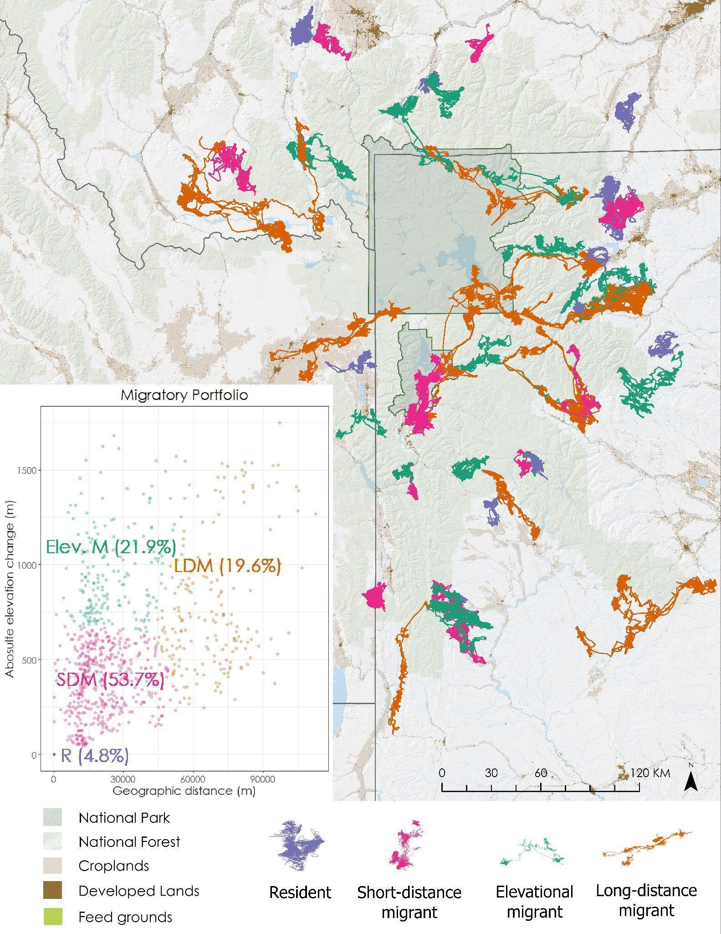**Figures**

Figure 1

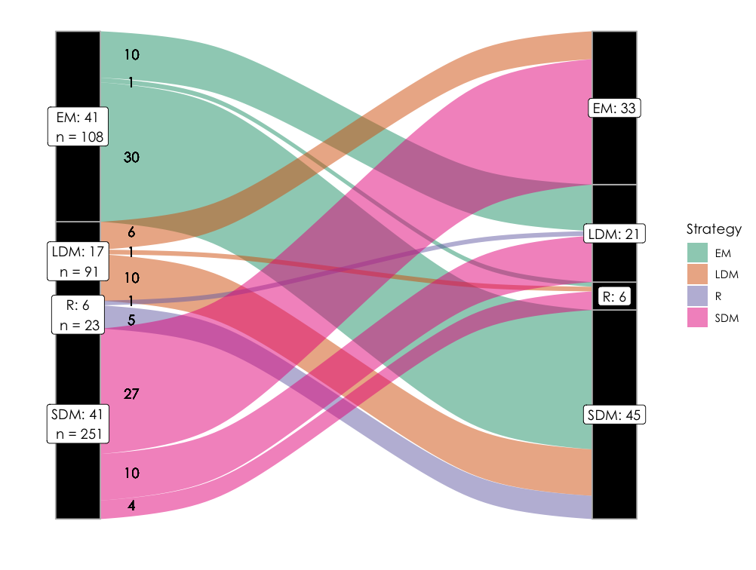

Figure 2

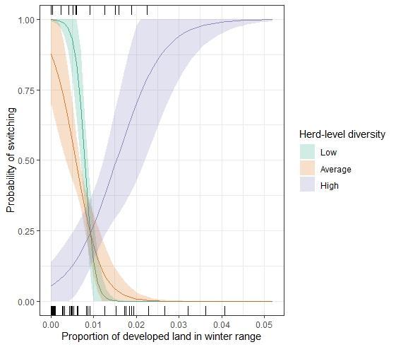

Figure 3

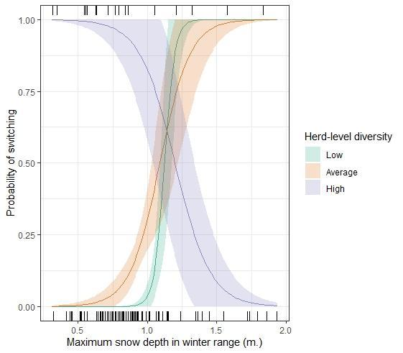

Figure 4

**Supplemental information**

*Appendix A.*

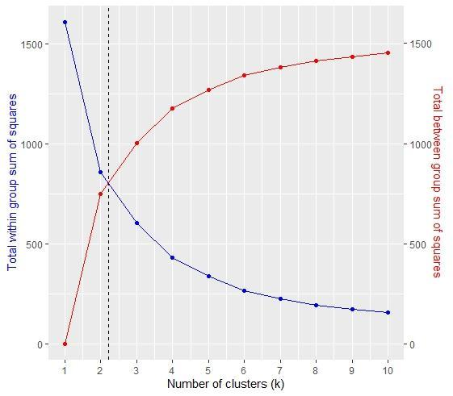

We performed k-means on scaled and centered data. We evaluated the plots to identify k such that the within group sum of squared Euclidean distances was minimized, but the between group sum of squared distances was maximized (Lowrey et al. 2020). The optimal value falls between k = 2 and k = 3. Thus, we evaluated both to identify which fit our study system better.

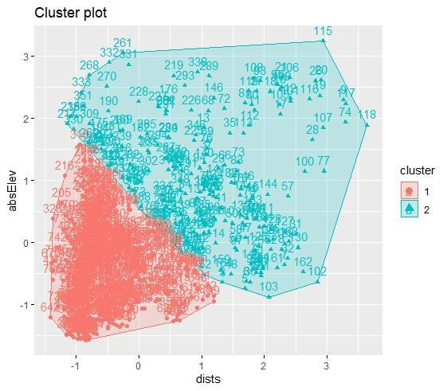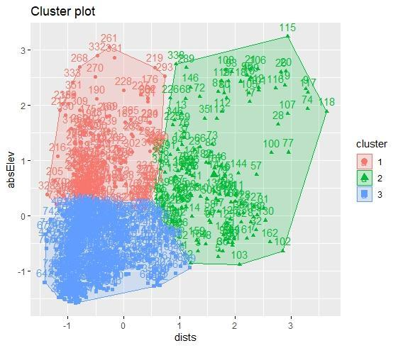A. B.

Fig. A. shows the k-means classification with k = 3 and Fig. B shows classification with k = 2. Given our knowledge of the GYE, we knew that elevational migrants (cluster 1 in Fig. A) were present in the system, thus we opted for k = 3.

*Appendix B.*

|  |  |  |  |  |  |
| --- | --- | --- | --- | --- | --- |
| **Herd** | **Elevational Migrant** | **Long Distance Migrant** | **Resident** | **Short Distance Migrant** | **Total** |
| **Afton** | **0** | **0** | **0** | **18** | **18** |
| **Blacktail** | **1** | **28** | **0** | **21** | **50** |
| **Clarks Fork** | **22** | **16** | **12** | **32** | **82** |
| **Cody** | **44** | **61** | **2** | **18** | **125** |
| **Fall Creek** | **5** | **0** | **0** | **7** | **12** |
| **Gooseberry** | **8** | **0** | **1** | **3** | **12** |
| **Greeley** | **0** | **0** | **0** | **10** | **10** |
| **Green River** | **7** | **3** | **4** | **18** | **32** |
| **Hoback** | **6** | **0** | **0** | **2** | **8** |
| **Jackson** | **14** | **20** | **0** | **120** | **154** |
| **Madison** | **2** | **2** | **0** | **5** | **9** |
| **Mill Creek** | **20** | **0** | **5** | **20** | **45** |
| **North Madison** | **2** | **0** | **8** | **24** | **34** |
| **Northern** | **6** | **2** | **0** | **0** | **8** |
| **Pinedale** | **4** | **0** | **0** | **4** | **8** |
| **Piney** | **13** | **4** | **6** | **98** | **121** |
| **Silver Run** | **2** | **0** | **1** | **2** | **5** |
| **South Wind River** | **5** | **9** | **0** | **8** | **22** |
| **Targhee** | **4** | **8** | **1** | **29** | **42** |
| **Wiggins Fork** | **19** | **12** | **0** | **12** | **43** |

Table showing the distribution of movement tactics across the 20 herds across all years used in the study. Numbers represent elk-years, not individual elk.

*Appendix C.*

|  |  |  |  |  |  |  |  |  |  |  |  |  |  |
| --- | --- | --- | --- | --- | --- | --- | --- | --- | --- | --- | --- | --- | --- |
|  | **Int.** | **Win. range prop. dev : herd-lvl. mig. div.** | **herd-lvl. mig. div.** | **Win. range prop. dev** | **Spr. mig. range prop. dev** | **F.g. access** | **Mean days-from-peak green-up** | **k** | **logLik** | **AICc** | **Delta** | **AICc Weight** | **MCC** |
| ***Top-ranked*** | **-0.55** | **3.13\*** | **-0.56\*** | **-3.31\*** | **—** | **—** | **—** | **4** | **-68.42** | **145.23** | **0** | **0.15** | **0.21** |
| ***Null*** | **-0.49** | **—** | **—** | **—** | **—** | **—** | **—** | **1** | **-71.70** | **145.44** | **0.21** | **—** | **0** |
| ***Model2*** | **-0.50** | **—** | **—** | **-0.17** | **—** | **—** | **—** | **2** | **-71.37** | **146.85** | **1.62** | **0.07** | **0** |
| ***Model5*** | **-0.49** | **—** | **—** | **—** | **—** | **—** | **-0.16** | **2** | **-71.38** | **146.88** | **1.65** | **0.07** | **0** |
| ***Model 3*** | **-0.49** | **—** | **—** | **—** | **0.15** | **—** | **—** | **2** | **-71.43** | **146.97** | **1.74** | **0.06** | **0.12** |
| ***Model 4*** | **-0.49** | **—** | **—** | **—** | **—** | **-0.12** | **—** | **2** | **-71.53** | **147.18** | **1.95** | **0.06** | **0** |

Model selection table of the six competitive models for switching from an elevational migrant tactic. * indicates informative covariates with 85% confidence intervals that do not overlap 0 (Arnold, 2010).

*Appendix D.*

|  |  |  |  |  |  |  |  |  |  |  |
| --- | --- | --- | --- | --- | --- | --- | --- | --- | --- | --- |
|  | **Int.** | **Spr. mig. range prop. dev. : herd-lvl. mig. div.** | **Herd-lvl. mig. div.** | **Spr. mig. range prop. dev.** | **k** | **logLik** | **AICc** | **Delta** | **AICc Weight** | **MCC** |
| ***Top-ranked*** | **-3.31** | **-3.48** | **0.88\*** | **-0.73** | **4** | **-92.45** | **193.06** | **0** | **0.97** | **0.25** |

Model selection table of the one competitive model for switching from a short distance migrant tactic. * indicates informative covariates with 85% confidence intervals that do not overlap 0 (Arnold, 2010).

*Appendix E.*

|  |  |  |  |  |  |  |  |  |  |  |  |  |
| --- | --- | --- | --- | --- | --- | --- | --- | --- | --- | --- | --- | --- |
|  | **Int.** | **Max. snow : herd-lvl. mig. div.** | **Herd-lvl. mig. div.** | **Max. snow on win. range** | **Spr. mig. range prop. dev.** | **Mean days-from-peak green-up** | **k** | **logLik** | **AICc** | **Delta** | **AICc Weight** | **MCC** |
| ***Top-ranked*** | **-1.69** | **-3.63\*** | **2.37\*** | **3.30\*** | **—** | **—** | **4** | **-39.62** | **87.70** | **0** | **0.17** | **0.31** |
| ***Model 21*** | **-1.56** | **—** | **—** | **-0.50\*** | **0.59\*** | **—** | **3** | **-41.21** | **88.70** | **1.00** | **0.10** | **0.12** |
| ***Model 3*** | **-1.50** | **—** | **—** | **—** | **0.39\*** | **—** | **2** | **-42.39** | **88.91** | **1.21** | **0.09** | **0.12** |
| ***Model 20*** | **-1.54** | **—** | **—** | **—** | **0.42\*** | **0.32** | **3** | **-41.46** | **89.20** | **1.50** | **0.08** | **0.31** |
| ***Null*** | **-1.47** | **—** | **—** | **—** | **—** | **—** | **1** | **-43.82** | **89.69** | **1.99** | **—** | **0** |

Model selection table of the five competitive models for switching from a long distance migrant tactic. * indicates informative covariates with 85% confidence intervals that do not overlap 0 (Arnold, 2010).